[arrow_back](https://accounts.google.com/)

Introduction to Git

help

Introduction to Git

1 hour 30 minutesFree

Rate Lab

**Introduction**

In this scenario, you are a project lead in an IT company. You and your team are working on a huge project, which consists of multiple functionalities and modules. This project is evolving over time and so your team is expecting a lot of code revisions. In this lab, you'll learn how to use a distributed version control system called Git. You'll also discover how to connect to a VM instance, install Git, and configure your Git user information. Next, you'll create a local Git repository, add a file to the repository, and do some basic operations like adding a file, editing files, and making commits.

**What you'll do**

* Create a git repository.
* Add files to this repository
* Edit the files
* Commit the changes to the repository.

You'll have 90 minutes to complete this lab.

Start the lab

You'll need to start the lab before you can access the materials in the virtual machine OS. To do this, click the green “Start Lab” button at the top of the screen.

**Note:** For this lab you are going to access the **Linux VM** through your **local SSH Client**, and not use the **Google Console** (**Open GCP Console** button is not available for this lab).

Start Lab

After you click the “Start Lab” button, you will see all the SSH connection details on the left-hand side of your screen. You should have a screen that looks like this:

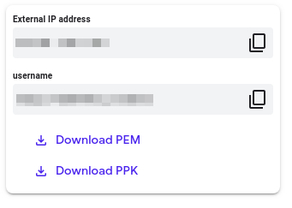

**Accessing the virtual machine**

Please find one of the three relevant options below based on your device's operating system.

**Note:** Working with Qwiklabs may be similar to the work you'd perform as an **IT Support Specialist**; you'll be interfacing with a cutting-edge technology that requires multiple steps to access, and perhaps healthy doses of patience and persistence(!). You'll also be using **SSH** to enter the labs -- a critical skill in IT Support that you’ll be able to practice through the labs.

Option 1: Windows Users: Connecting to your VM

In this section, you will use the PuTTY Secure Shell (SSH) client and your VM’s External IP address to connect.

**Download your PPK key file**

You can download the VM’s private key file in the PuTTY-compatible **PPK** format from the Qwiklabs Start Lab page. Click on **Download PPK**.

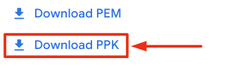

**Connect to your VM using SSH and PuTTY**

1. You can download Putty from [here](https://the.earth.li/~sgtatham/putty/latest/w64/putty.exe)
2. In the **Host Name (or IP address)** box, enter username@external_ip_address.

**Note:** Replace **username** and **external_ip_address** with values provided in the lab.



1. In the **Category** list, expand **SSH**.
2. Click **Auth** (don’t expand it).
3. In the **Private key file for authentication** box, browse to the PPK file that you downloaded and double-click it.
4. Click on the **Open** button.

**Note:** PPK file is to be imported into PuTTY tool using the Browse option available in it. It should not be opened directly but only to be used in PuTTY.



1. Click **Yes** when prompted to allow a first connection to this remote SSH server. Because you are using a key pair for authentication, you will not be prompted for a password.

**Common issues**

If PuTTY fails to connect to your Linux VM, verify that:

* You entered **<username>**@**<external ip address>** in PuTTY.
* You downloaded the fresh new PPK file for this lab from Qwiklabs.
* You are using the downloaded PPK file in PuTTY.

Option 2: OSX and Linux users: Connecting to your VM via SSH

**Download your VM’s private key file.**

You can download the private key file in PEM format from the Qwiklabs Start Lab page. Click on **Download PEM**.

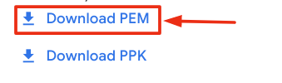

**Connect to the VM using the local Terminal application**

A **terminal** is a program which provides a **text-based interface for typing commands**. Here you will use your terminal as an SSH client to connect with lab provided Linux VM.

1. Open the Terminal application.
   * To open the terminal in Linux use the shortcut key **Ctrl+Alt+t**.
   * To open terminal in **Mac** (OSX) enter **cmd + space** and search for **terminal**.
2. Enter the following commands.

**Note:** Substitute the **path/filename for the PEM** file you downloaded, **username** and **External IP Address**.

You will most likely find the PEM file in **Downloads**. If you have not changed the download settings of your system, then the path of the PEM key will be **~/Downloads/qwikLABS-XXXXX.pem**

chmod 600 ~/Downloads/qwikLABS-XXXXX.pem

ssh -i ~/Downloads/qwikLABS-XXXXX.pem username@External Ip Address

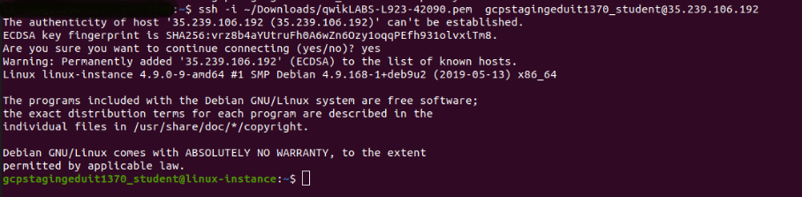

Option 3: Chrome OS users: Connecting to your VM via SSH

**Note:** Make sure you are not in **Incognito/Private mode** while launching the application.

**Download your VM’s private key file.**

You can download the private key file in PEM format from the Qwiklabs Start Lab page. Click on **Download PEM**.



**Connect to your VM**

1. Add Secure Shell from [here](https://chrome.google.com/webstore/detail/secure-shell-app/pnhechapfaindjhompbnflcldabbghjo) to your Chrome browser.
2. Open the Secure Shell app and click on **[New Connection]**.

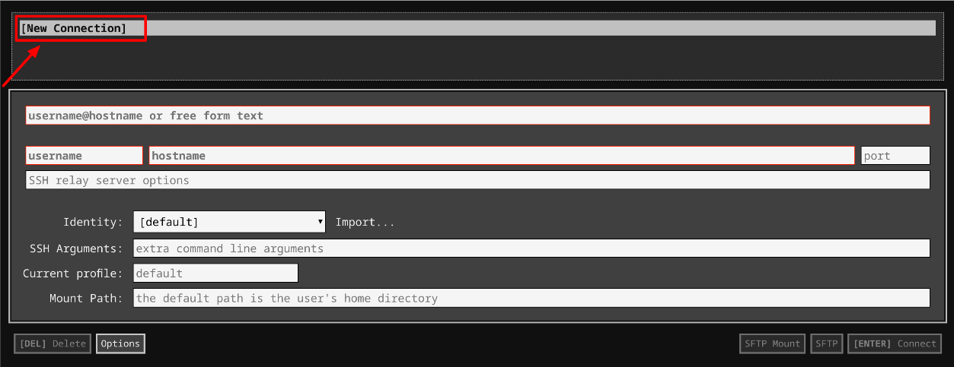

1. In the **username** section, enter the username given in the Connection Details Panel of the lab. And for the **hostname** section, enter the external IP of your VM instance that is mentioned in the Connection Details Panel of the lab.

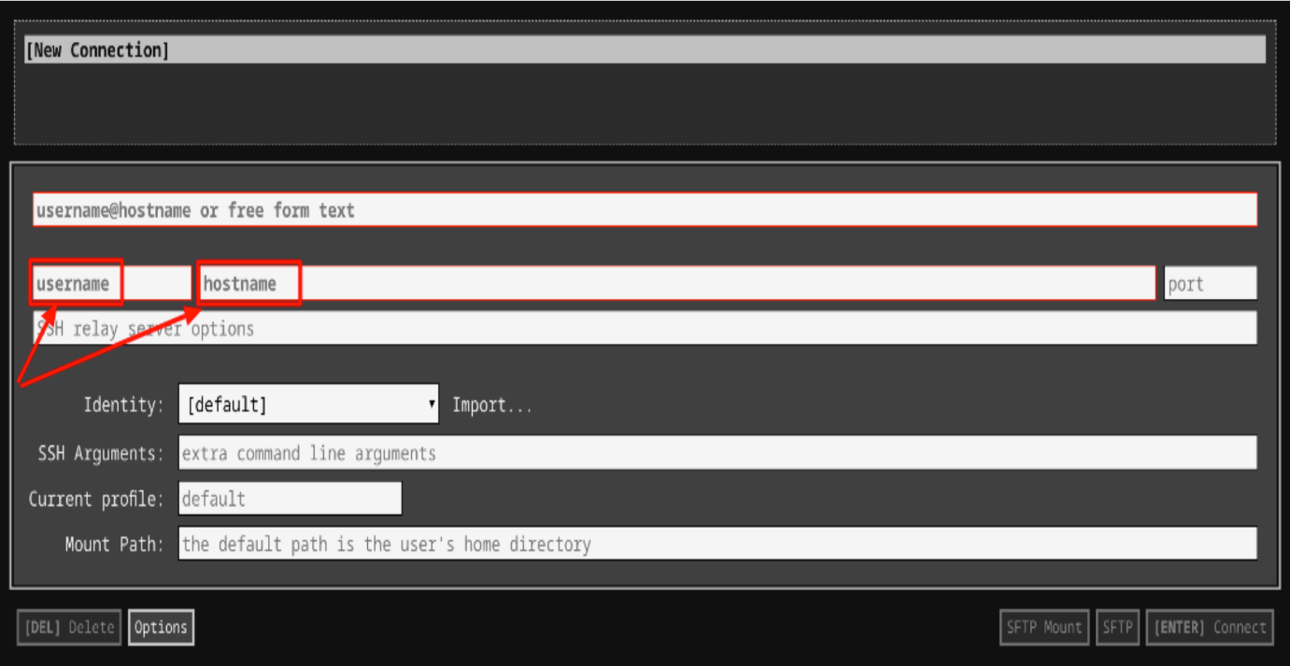

1. In the **Identity** section, import the downloaded PEM key by clicking on the **Import…** button beside the field. Choose your PEM key and click on the **OPEN** button.

**Note:** If the key is still not available after importing it, refresh the application, and select it from the **Identity** drop-down menu.

1. Once your key is uploaded, click on the **[ENTER] Connect** button below.

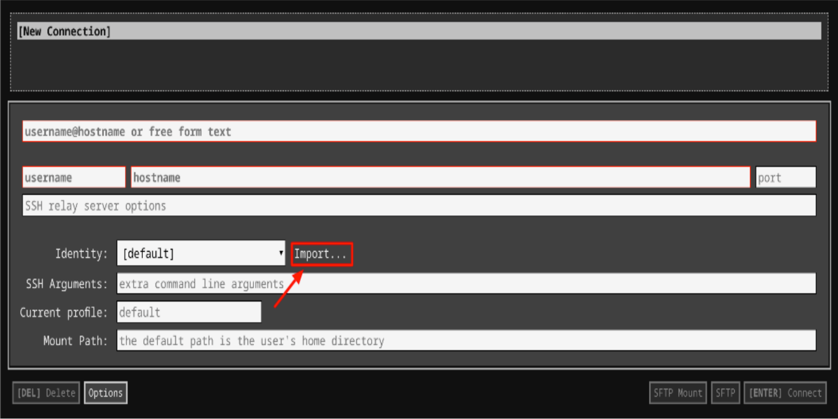

6. For any prompts, type **yes** to continue.

7. You have now successfully connected to your Linux VM.

You're now ready to continue with the lab!

**Install Git**

Before you install Git on your Linux VM, you need to first make sure that you have a fresh index of the packages available to you. To do that, run:

sudo apt update

Now, you can install Git on your Linux host using apt by running the following command:

sudo apt install git

For any prompts, continue by clicking Y.

Check the installed version of git by using the command below:

git --version

Click *Check my progress* to verify the objective.

Install git

Check my progress

**Initialize a new repository**

Create a directory to store your project in. To do this, use the following command:

mkdir my-git-repo

Now navigate to the directory you created.

cd my-git-repo

Next, initialize a new repository by using the following command:

git init

The **git init** command creates a new Git repository. In our case, it transformed the current directory into a Git repository. It can also be used to convert an existing, unversioned project to a Git repository or to initialize a new, empty repository.

Executing **git init** creates a **.git** subdirectory in the current working directory, which contains all of the necessary Git metadata for the new repository. This metadata includes subdirectories for objects, refs, and template files. A HEAD file is also created which points to the currently checked out commit.

If you've already run **git init** on a project directory containing a **.git** subdirectory, you can safely run **git init** again on the same project directory. The operation is what we call *idempotent*; running it again doesn't override an existing **.git** configuration.

**Configure Git**

Git uses a username to associate commits with an identity. It does this by using the **git config** command. To set Git username use the following command:

git config --global user.name "Name"

Replace **Name** with your name. Any future commits you push to GitHub from the command line will now be represented by this name. You can use **git config** to even change the name associated with your Git commits. This will only affect future commits and won't change the name used for past commits.

Let's set your email address to associate it with your Git commits.

git config --global user.email "user@example.com"

Replace **user@example.com** with your email-id. Any future commits you now push to GitHub will be associated with this email address. You can even use **git config** to change the user email associated with your Git commits.

**Git Operations**

Let's now create a text file named README. We will be using the nano editor for this.

nano README

Type any text within the file, or you can use the following text:

This is my first repository.

Save the file by pressing Ctrl-o, Enter key, and Ctrl-x.

Git is now aware of the files in the project. We can check the status using the following command:

git status

This command displays the status of the working tree. It also shows changes that have been staged, changes that haven't been staged, and files that aren't tracked by Git.

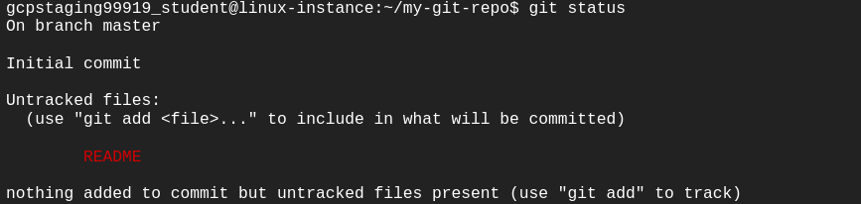

You can now see the file you created, README, under the section **Untracked files**. Git isn't tracking the files yet. To track the files, we have to commit these files by adding them to the staging area.

Now let's add the file to the staging area using the following command:

git add README

This command adds changes from the working tree to the staging area i.e., it gathers and prepares files for Git before committing them. In other words, it updates the index with the current content found in the working tree to prepare the content that's staged for the next commit.

You can now view the status of the working tree using the command: **git status**. This now shows the file **README** in green i.e., the file is now in the staging area and yet to be committed.

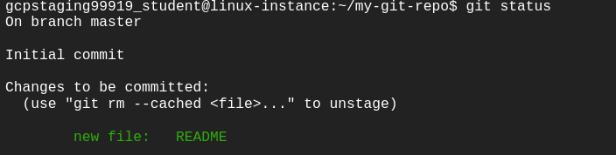

However, **git add** doesn't affect the repository in any serious way because changes are not actually recorded until you commit them.

Let's now commit the changes. A Git commit is equivalent to the term "Save".

Commit the changes using the following command:

git commit

This now opens an editor, asking you to type a commit message. Every commit has an associated commit message. A commit message is a log message from the user describing the changes.

Enter the commit message of your choice or you can use the following text:

This is my first commit!

Once you have entered the commit message, save it by pressing Ctrl-o and Enter key. To exit click Ctrl-x.

The **git commit** command captures a snapshot of the project's currently staged changes i.e., it stores the current contents of the index in a new commit along with the commit message.

Click *Check my progress* to verify the objective.

First commit

Check my progress

You have successfully committed your file!

Let's now re-edit the file again to understand the process better. Open the file README using nano editor.

nano README

Now add another line of description for your repository below the earlier entered line. Add the description of your choice or you can use the following text:

A repository is a location where all the files of a particular project are stored.

Save and exit the editor by pressing Ctrl-o, Enter key, and Ctrl-x.

Now, let's repeat the previous process. As mentioned earlier, you can always check the status of your repository by using:

git status

To understand the difference, compare with the earlier scenario where you added the new file to the repository.

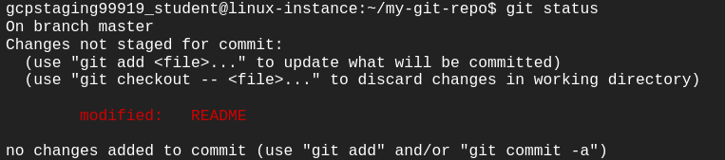

Git tracks the changes and displays that the file has been modified. You can view the changes made to file using the following command:

git diff README

You can see the differences between the older file and the new file. New additions are denoted by green-colored text and a + sign at the start of the line. Any replacements/removal are denoted by text in red-colored text and a - sign at the start of the line.

Now, we will add these changes to the staging area.

git add README

View the status of the repository using the following command:

git status

Git now shows the same file in green-colored text. This means the changes are staged and ready to be committed.

Let's commit the file now by entering the commit message with the command itself, unlike the previous commit.

git commit -m "This is my second commit."

The command **git commit** with -m flag takes the commit message, too. This is different to the command without flag, where you had to type the commit message within the editor. If multiple **-m** flags are given to the command, it concatenates the values as separate paragraphs.

To view all the commits use the following command:

git log

Git log command shows the commit history of the repository. It shows all the commits on the repository represented by a unique commit ID at the top of each commit. It also shows the author, date, and time and the commit message associated with the commits.

You also have various options to limit the output of this command. The output can be filtered based on the last number of commits, author, commit message, etc.

Click *Check my progress* to verify the objective.

Second commit

Check my progress

**Congratulations!**

Congrats! You've successfully installed the Git, initialized a repository, and performed basic Git operations. Now that you know how to do this, it will be easier for you and your team to work on a huge project with multiple functionalities and modules.

**End your lab**

When you have completed your lab, click **End Lab**. Qwiklabs removes the resources you’ve used and cleans the account for you.

You will be given an opportunity to rate the lab experience. Select the applicable number of stars, type a comment, and then click **Submit**.

The number of stars indicates the following:

* 1 star = Very dissatisfied
* 2 stars = Dissatisfied
* 3 stars = Neutral
* 4 stars = Satisfied
* 5 stars = Very satisfied

You can close the dialog box if you don't want to provide feedback.

For feedback, suggestions, or corrections, please use the **Support** tab.